Low-ESR, low-ESL, low-profile – in high quality
Panasonic Industry to set focus on superior SP-Cap Polymer Capacitor technology
Munich, JUNE 2020
Wherever a minimal ESR is the primary consideration for identifying the most suitable capacitor, the latest SP-Cap innovations from Panasonic Industry are likely to become the new flagship of „Super Low“.

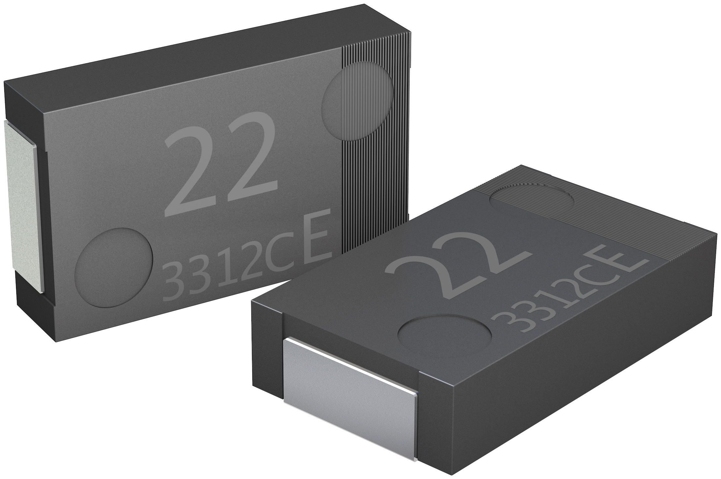
Speaking in numbers, the SP-Cap with 3 mΩ has the lowest Equivalent Series Resistance for this technology in the market. This must be considered as unrivaled at present - and makes the Polymer Technology a highly relevant option for microprocessor-based assemblies. SP-CAP’s specifications promise a more than sound performance within contemporary and complex low-profile electronical devices: Capacitance counts up to a maximum of remarkable 820 µF and – not least to mention – a ripple current capacity up to 10.200 mA rms.

“Although all that might sound like a footnote of electronical engineering – it isn‘t“, Shahrokh Kananizadeh, the product manager of Panasonic Industry Europe explains. “It is exactly that very composition of ESR, capacitance and ripple current tolerance that make a capacitor an outstanding capacitor. One that turns out in the end of the day to be a crucial component for the long term reliability or - on the contrary - its faultiness.“
Additionally, Polymer Technology of Panasonic Industry especially SP-CAP, has already proven it can be great replacement for Multi-Layer ceramic capacitors and Pure Tantalum capacitors by offering fewer number of parts being mounted on PCBs and having better performance as well.

Panasonic Industry is planning on expanding SP-CAP portfolio by focusing more on longer endurance and higher reliable products. With this latest innovation Panasonic Industry reinforces again its market-leading position in the field of polymer capacitor technology that can be reliably operated within a wide range of temperature.

“A matter of course“, as Shahrokh Kananizadeh says, “as sustainability has to literally start with the small parts, Panasonic Industry Polymer technology will be a big contribution to this trend”.

Further information can be found LINK here.

__________
About Panasonic
Panasonic Corporation is a global leader developing innovative technologies and solutions for wide-ranging applications in the consumer electronics, housing, automotive, and B2B sectors. The company, which celebrated its 100th anniversary in 2018, operates 528 subsidiaries and 72 associated companies worldwide and reported consolidated net sales of 61.9 billion Euro (7.49 trillion yen) for the year ended March 31, 2020. Committed to pursuing new value through collaborative innovation, the company uses its technologies to create a better life and a better world for customers.
To learn more about Panasonic: http://www.panasonic.com/global

About Panasonic Industry Europe
Panasonic Industry Europe GmbH is part of the global Panasonic Group and provides automotive and industrial products and services in Europe. As a partner for the industrial sector, Panasonic researches, develops, manufactures and supplies technologies that support the slogan “A Better Life, A Better World”.
The company’s portfolio covers key electronic components, devices and modules up to complete solutions and production equipment for manufacturing lines across a broad range of industries. Panasonic Industry Europe is part of the global company Panasonic Industrial Solutions.
More about Panasonic Industry Europe: http://industry.panasonic.eu

